AI-Powered Clothing App for Personalized Outfit Recommendation

By

Sia Jin Sheng



FACULTY OF COMPUTING AND

INFORMATION TECHNOLOGY

TUNKU ABDUL RAHMAN UNIVERSITY OF MANAGEMENT AND TECHNOLOGY

KUALA LUMPUR

ACADEMIC YEAR

2025/26

AI-Powered Clothing App for Personalized Outfit Recommendation

By

Sia Jin Sheng

Supervisor: Ms SITI NADIAH BINTI NAIN

A project report submitted to the

Faculty of Computing and Information Technology

in partial fulfillment of the requirement for the

Bachelor of Information Technology (Honours) in Software Systems Development

Faculty of Computing and Information Technology

Tunku Abdul Rahman University of Management and Technology

Kuala Lumpur

Copyright by Tunku Abdul Rahman University of Management and Technology.

All rights reserved. No part of this project documentation may be reproduced, stored in retrieval system, or transmitted in any form or by any means without prior permission of Tunku Abdul Rahman University of Management and Technology.

Declaration

The project submitted herewith is a result of my own efforts in totality and in every aspect of the project works. All information that has been obtained from other sources had been fully acknowledged. I understand that any plagiarism, cheating or collusion or any sorts constitutes a breach of TAR University rules and regulations and would be subjected to disciplinary actions.



__________________________

Sia Jin Sheng
Bachelor of Information Technology (Honours) in Software Systems Development
ID: 24WMR16773

Abstract
This project presents the development of an AI-powered clothing mobile application designed to provide personalized outfit recommendations based on a user’s height, weight, gender, and preferred fashion style. The project addresses the common challenge faced by online shoppers who struggle to select clothing that fits their personal style and body measurements, often resulting in dissatisfaction and product returns. By integrating machine learning-based recommendation logic with a mobile user interface, the system aims to enhance user confidence during the shopping process and improve product discovery.
The scope of the project includes the construction of a Flutter-based mobile application, a backend service for AI processing, and a structured database storing product, user, and recommendation data. Core features include user authentication, product browsing, cart management, wishlist, order simulation, and AI-generated outfit recommendations tailored to individual user profiles.
The system employs a rule-based filtering model combined with similarity scoring to compute personalized recommendations. Firebase Authentication, real-time database storage, and REST API communication were used throughout development. Testing involved functional validation of user flows, UI/UX testing, and evaluation of the AI recommendation accuracy using predefined scenarios.
The results show that the developed application successfully provides relevant outfit suggestions and delivers smooth user interaction. While the AI model is lightweight and suitable for prototype use, future improvements may include implementing a deeper learning model and expanding the dataset for better personalization. Overall, the project demonstrates the feasibility of integrating AI-driven recommendations into a mobile shopping application and provides a solid foundation for future enhancements.

Acknowledgement

I would like to express my sincere gratitude to my supervisor, Ms. Siti Nadiah Binti Nain, for her guidance, support, and constructive feedback throughout the duration of this project. Her encouragement and expertise have been invaluable in shaping the direction and quality of this work. I would also like to thank the lecturers and moderators who provided academic insights and support along the way. My heartfelt appreciation goes to my family and friends for their continuous motivation, understanding, and patience during the development of this project. Their support has been instrumental to the successful completion of this work.

Chapter 1: Introduction 8
1.1 Project Objectives 8
1.2 Project Background 8
1.3 Advantages and Contributions 9
1.3.1 Advantages for Consumers 9
1.3.2 Contributions to the Industry 9
1.3.3 Contributions to Research 9
1.4 Project Plan 10
1.5 Project Team and Organization 10
1.6 Chapter Summary and Evaluation 11
Chapter 2: Literature Review 12
2.1 Introduction 12
2.2 Related Studies on Fashion Recommendation Systems 12
2.3 Artificial Intelligence and Machine Learning in Fashion 12
2.4 E-Commerce Application Features and Design 13
2.5 Related Systems Comparison 13
2.6 Summary and Evaluation 14
2.7 Reference 14
Chapter 3: Methodology And Requirements Analysis 15
3.1 Introduction 15
3.2 Methodology 15
3.2.1 Selected Development Model: Agile Development 15
3.2.2 Advantages of Agile for This Project 15
3.3 Requirements Gathering Techniques 16
3.4 Requirements Analysis 16
3.4.1 Use Case Diagram 16
3.4.2 Data Flow Diagram (DFD) – Level 0 17
3.5 Functional and Non-Functional Requirements 17
3.5.1 Functional Requirements 17
3.5.2 Non-Functional Requirements 18
3.6 Chapter Summary and Evaluation 18
CHAPTER 4 – SYSTEM DESIGN 19
4.1 System Overview / Workflow Design 19
4.1.1 System Workflow Steps 19
4.1.2 Workflow Diagram (Description) 22
4.2 User Interface (UI) / System Interaction Design 22
4.2.1 UI Wireframe Description 22
Home Screen 24
Login & Registration Screen 24
Product List Screen 24
Product Details Screen 24
AI Recommendation Screen 24
Cart & Checkout Screen 24
User Profile Screen 25
4.3 Data Design 25
4.3.1 Entity Relationship Diagram (ERD) 25
4.3.2 Class Diagram 26
4.3.3 Database Schema 27
Table: User 27
Table: Category 28
Table: Product 28
Table: Quantity (Product Variant) 28
Table: Cart 28
Table: Orders 29
Table: Order_Details 29
Table: Address 29
Table: Delivery 30
Table: Payment 30
Table: Payment_Method 31
Table: AIRecommendation 31
4.4 Software Architecture Design 32
4.4.1 Layers 32
4.4.2 Architecture Diagram 33
4.5 Process Design 33
4.5.1 Login Validation Process 33
4.5.2 AI Recommendation Process 33
4.5.3 Simulated Payment Process 34
4.6 Algorithm / Model Design 34
4.6.1 Algorithm Overview and Justification 34
4.6.2 Model Input Features 35
User Features 35
Product Features 35
4.6.3 Model Architecture 35
Model Layers 35
4.6.4 Activation & Loss Functions 35
4.6.5 Compatibility Scoring Formula 36
4.6.6 Final Prediction Equation 36
4.7 Security Design 36
Security Measures Implemented 36
4.8 Chapter Summary and Evaluation 37

Chapter 1: Introduction

1.1 Project Objectives
The primary goal of this project is to design and develop a mobile fashion e-commerce application that addresses the limitations of existing platforms by integrating artificial intelligence (AI) for personalized outfit recommendations. Traditional e-commerce applications such as those offered by H&M, Uniqlo, Zara, and Padini provide product browsing, cart management, and user accounts but lack a strong emphasis on personalization tailored to individual users.
To bridge this gap, the objectives of the project are as follows:
- Develop a comprehensive mobile application for online clothing retail that includes standard e-commerce functionalities such as product browsing by category, cart and wishlist management, and secure authentication. This ensures that the system can meet basic user expectations while serving as a functional shopping platform.
- Implement an AI-powered recommendation engine that uses users’ body profile information (e.g., height and weight) and preferred fashion styles (e.g., Japanese, Korean, European) to suggest appropriate outfits. Unlike generic recommendation engines that rely on purchase history or collaborative filtering, this engine aims to generate personalized and practical recommendations aligned with user needs.
- Enhance customer engagement through value-added features such as wishlist creation, product reviews, ratings, and user profile customization. These features allow customers to interact more actively with the platform, improving trust and satisfaction.
- Improve user experience by reducing time spent searching for appropriate items and minimizing frustration from purchasing clothes that do not fit or suit their style. By doing so, the project also addresses the problem of high cart abandonment rates common in online fashion e-commerce.
- Contribute to inclusivity and cultural diversity in online shopping, as the system will cater to different body types and provide style recommendations influenced by multiple cultural fashion trends.
These objectives form the foundation of the project, ensuring that the final system not only replicates standard e-commerce features but also innovates by leveraging AI-driven personalization.

1.2 Project Background
The fashion and apparel industry represents one of the largest and fastest-growing segments of global e-commerce. In Southeast Asia, the market is expected to generate USD 53.45 billion in revenue by 2025, supported by an annual growth rate of 3.6% (Statista, 2023). This trend is largely driven by the region’s mobile-first consumer behavior, with 89% of internet users accessing the web primarily via smartphones (MarketResearchSEA, 2023). Moreover, 94% of urban internet users in the region engage in e-commerce, indicating strong adoption of digital shopping (Daxue Consulting, 2022).
Despite this promising growth, online fashion shopping remains fraught with challenges. One of the most significant problems is the lack of personalization. Shoppers often find it difficult to identify items that fit both their physical measurements and personal style preferences. Unlike in physical stores, customers cannot try on clothes before purchase, which often leads to mismatched sizing, dissatisfaction, and high product return rates. This inefficiency contributes to cart abandonment, with research showing that 82% of users abandon their shopping carts due to poor user experience (VWO, 2023).
Existing mobile applications developed by global fashion retailers primarily focus on replicating the in-store browsing experience, offering users a catalog of products, filtering options, and basic recommendations such as “customers who bought this also bought…” While these features provide some convenience, they fail to address the deeper needs of consumers who desire personalized suggestions that consider body type, style preferences, and cultural influences.
This project therefore seeks to fill this gap by creating an application that not only incorporates the standard e-commerce functions but also integrates an AI recommendation system. By analyzing both quantitative (body profile) and qualitative (stylistic preference) inputs, the system aims to provide users with more accurate and meaningful outfit suggestions.

1.3 Advantages and Contributions

1.3.1 Advantages for Consumers
The most immediate advantage of the proposed system is an improved user experience. Consumers will benefit from:
- Personalized recommendations that are based on both physical measurements and fashion preferences, ensuring that suggested outfits are more relevant and practical.
- Time-saving features, as users can quickly discover suitable products without having to browse through an extensive catalog.
- Increased confidence in purchasing, reducing the likelihood of returns and dissatisfaction.
- Engagement features such as ratings, comments, and wishlists that foster a sense of interaction similar to social commerce platforms.

1.3.2 Contributions to the Industry
From a business perspective, the application demonstrates how artificial intelligence can be practically applied to improve personalization in the fashion retail industry. This project contributes to the industry by:
- Reducing cart abandonment rates by offering better-targeted product suggestions.
- Encouraging inclusivity in fashion retail by catering to a wider variety of body types and cultural styles.
- Supporting trend adaptation, as the AI model can be updated with new datasets to reflect seasonal and cultural fashion changes.

1.3.3 Contributions to Research
The academic contribution of this project lies in exploring how AI can be applied in fashion e-commerce through a dual-input recommendation approach. While most recommendation systems rely solely on collaborative filtering or purchase history, this project integrates physical body data with style-specific datasets. This approach opens new avenues for research into more holistic recommendation engines that blend technical efficiency with cultural and stylistic adaptability.

1.4 Project Plan
The project will be developed in stages to ensure structured progress and proper evaluation:
- Phase 1: Core Services (July – September 2025)
  - Conduct background study and finalize system requirements.
  - Implement essential app features such as product browsing, account management, shopping cart, and simulated checkout.
  - Develop and integrate the AI-powered recommendation engine for personalized outfit suggestions.
- Phase 2: Extended Services (October – December 2025)
  - Add wishlist functionality, ratings, and comments.
  - Build user profile management features (edit details, view history).
  - Optionally design and implement an admin panel for product management.
- Phase 3: Testing and System Preview (January – March 2026)
  - Create detailed test plans and test cases.
  - Conduct functional, usability, and performance testing.
  - Present a prototype for review and refine based on feedback.
- Phase 4: Finalization and Documentation (March – April 2026)
  - Complete integration of all features.
  - Finalize report submission and system documentation.
This phased approach ensures that the project is completed on time while allowing room for testing, feedback, and improvements.

1.5 Project Team and Organization
This project is undertaken by:
- Student Researcher: Sia Jin Sheng (RSD2S3 G6)
- Supervisor: Ms. Siti Nadiah Binti Nain
As this is an individual project, the student researcher is responsible for all aspects, including system design, development, testing, and documentation. The supervisor’s role is to provide academic guidance, monitor progress, and evaluate deliverables at each milestone.
The project organization follows a simple structure:
- Student: Responsible for technical implementation, research, and reporting.
- Supervisor: Provides oversight, ensures project relevance, and assesses quality.
This lean structure ensures efficient communication and accountability throughout the project lifecycle.

1.6 Chapter Summary and Evaluation
This chapter introduced the project by highlighting its objectives, background, advantages, contributions, plan, and organization. The project addresses a pressing gap in the online fashion retail industry, where personalization remains limited despite technological advances. By integrating AI with e-commerce, the project seeks to create a platform that not only meets basic consumer needs but also enhances inclusivity and personalization.
The evaluation of this chapter indicates that the proposed system:
- Aligns with industry growth trends in Southeast Asia.
- Offers clear consumer, industrial, and academic contributions.
- Has a feasible implementation plan with defined phases and milestones.
The foundation established in this chapter provides the basis for the following sections. Chapter 2 will present a detailed literature review, examining existing works on AI in e-commerce, recommendation systems, and fashion retail applications.

Chapter 2: Literature Review

2.1 Introduction
This chapter reviews existing studies, technologies, and related systems relevant to the development of an AI-powered clothing e-commerce application. It focuses on fashion recommender systems, machine learning techniques, AI-based personalization, and e-commerce design practices. The aim is to establish the theoretical and practical foundation for the proposed system.

2.2 Related Studies on Fashion Recommendation Systems
Fashion recommender systems (FRS) use machine learning algorithms to suggest clothing items based on user preferences, purchase history, or visual similarity. According to Liu et al. (2023), hybrid recommender systems that combine user-based and content-based filtering show improved accuracy in fashion-related recommendations.
Existing research also explores the integration of body measurement data into fashion recommendations. For instance, Park and Yoo (2022) demonstrated that user height and weight can significantly enhance the relevance of outfit suggestions compared to purely visual-based models. However, few applications combine physical measurements with stylistic preferences such as cultural fashion styles (e.g., Japanese or Korean aesthetics).

2.3 Artificial Intelligence and Machine Learning in Fashion
AI and machine learning play a major role in enabling personalization in fashion retail. Deep learning techniques such as Convolutional Neural Networks (CNNs) are often applied to clothing image recognition, while Natural Language Processing (NLP) models are used for product description matching.
The proposed system will utilize a pre-trained recommendation model that can interpret numeric (height, weight) and categorical (style preference) data to recommend suitable outfits. Using a pre-trained model reduces training time and ensures feasibility within the FYP duration.
Algorithm | Application in Fashion | Relevance to Project
Collaborative Filtering | Recommends based on similar users | Low—does not use personal data
Content-Based Filtering | Matches items by attributes (e.g., color, type) | Medium—suitable for style tags
Hybrid Model | Combines both user and item data | High—used in this project
Deep Neural Networks | Learns complex relationships between user and item | High—enhances personalization

2.4 E-Commerce Application Features and Design
E-commerce applications such as H&M, Uniqlo, and Zara offer essential features including product browsing, wishlists, carts, and user authentication. However, their recommendation systems are often limited to category-based filters or trending products.
Research by Chiu and Wong (2021) found that AI-driven personalization increases customer engagement by 35% in e-commerce environments. Thus, incorporating AI recommendations, ratings, and feedback mechanisms is key to enhancing user experience and loyalty.
Core e-commerce design considerations include:
- Usability: Simple, clean interfaces that support efficient browsing.
- Security: Safe authentication and data protection measures.
- Responsiveness: Mobile-first design ensuring cross-platform compatibility.

2.5 Related Systems Comparison
System | Features | AI Recommendation | Personalization | Limitation
H&M App | E-commerce browsing, cart, wishlist | No | Limited to filters | No personalization based on body data
Uniqlo App | Product listing, store locator, membership | No | Based on purchase history | No AI recommendation
Zalora | Product browsing, recommendation by brand | Basic collaborative filtering | Moderate | Does not consider style or body profile
Proposed System | AI recommendation, product feedback, style-based suggestion | Yes | High | Will be developed
The proposed system differs from competitors by integrating user body profile and style preferences into AI-driven outfit recommendations.

2.6 Summary and Evaluation
This chapter reviewed the current literature and systems relevant to fashion recommendation applications. Studies indicate that AI and machine learning significantly improve personalization in fashion e-commerce. However, current market applications lack integration between body measurement data and cultural fashion preferences.
The proposed system fills this research and commercial gap by combining both dimensions, offering a hybrid recommendation model that improves inclusivity and personalization. This literature foundation supports the project’s innovation and technical feasibility.

2.7 Reference
- Chiu, T., & Wong, L. (2021). AI Personalization in E-Commerce: User Engagement and Purchase Intentions. Journal of Retail Technology, 14(3), 45–56.
- Liu, J., Zhang, M., & Li, S. (2023). A Hybrid Fashion Recommendation System Using Visual and Attribute Data. IEEE Transactions on Consumer Electronics.
- Park, Y., & Yoo, J. (2022). Body-Aware Fashion Recommendations: Integrating Anthropometric Data in AI Models. Computers in Industry, 139, 103–121.

Chapter 3: Methodology And Requirements Analysis

3.1 Introduction
This chapter outlines the methodology used in developing the proposed mobile clothing e-commerce application with AI-based outfit recommendations. It also discusses the requirements gathering process, requirement analysis (including diagrams), and the identification of functional and non-functional requirements. The aim is to ensure that the development process is systematic, practical, and aligned with the project objectives.

3.2 Methodology

3.2.1 Selected Development Model: Agile Development
The Agile development model was chosen due to its flexibility and suitability for projects that involve iterative improvements and evolving requirements. Since this project involves both AI integration and UI/UX optimization, Agile enables incremental progress through sprints, allowing feedback and adaptation at each stage.
Key Agile Phases:
- Planning: Define objectives, scope, and features.
- Design: Create system architecture and UI/UX mockups.
- Development: Implement core modules such as authentication, product management, and AI recommendation.
- Testing: Conduct functional and usability testing in each sprint.
- Review: Collect supervisor and user feedback for improvement.
- Deployment: Prepare the final, tested prototype for demonstration.

3.2.2 Advantages of Agile for This Project
- Allows continuous integration of AI and UI features.
- Supports dynamic adjustments based on supervisor feedback.
- Reduces project risks by ensuring deliverables at each sprint.
- Encourages collaboration and iterative testing.

3.3 Requirements Gathering Techniques
The requirements for the proposed system were collected through a combination of primary and secondary data collection methods.
Method | Description | Expected Outcome
Observation | Review of existing fashion e-commerce apps (H&M, Uniqlo, Zara, Zalora) | Identify common features and user interface standards
Online Surveys | Gather potential user preferences on AI outfit recommendations and privacy concerns | Understand user expectations and acceptance of AI features
Literature Review | Analyze existing research on recommender systems and e-commerce design | Identify technological gaps and feasible AI approaches
Consultation with Supervisor | Discuss scope, limitations, and risk management | Validate feasibility within the FYP timeframe

3.4 Requirements Analysis
The requirements analysis focuses on defining system components, data flow, and interactions between users and the system.

3.4.1 Use Case Diagram
Main Actors:
- User: Browse products, receive recommendations, rate/comment, manage profile.
- Admin: Manage product listings and monitor user activities.
Use Cases:
- User registration/login
- View and search products
- AI outfit recommendation
- Add to cart/wishlist
- Rate and comment on products
- Checkout
- Manage user profile
- Admin product management

3.4.2 Data Flow Diagram (DFD) – Level 0
Process Overview:
- User inputs personal details and style preferences.
- System retrieves relevant product data from the database.
- AI model processes inputs and generates outfit recommendations.
- User views recommended products and may add them to cart or wishlist.
- System stores user ratings and feedback for iterative improvement.

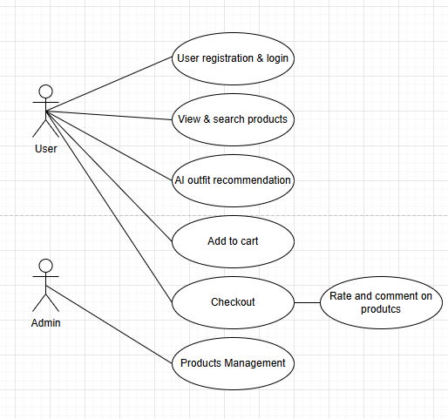

3.5 Functional and Non-Functional Requirements

3.5.1 Functional Requirements
ID | Description
FR1 | Users can register and log in securely.
FR2 | Users can browse clothing products by gender, category, and style.
FR3 | AI models recommend outfits based on height, weight, and style preference.
FR4 | Users can add items to cart or wishlist.
FR5 | Users can rate and comment on purchased or viewed items.
FR6 | Admin can manage product listings and review user activity.
FR7 | The system stores user data securely and retrieves it efficiently.
FR8 | The user can perform a payment during checkout to confirm an order.

3.5.2 Non-Functional Requirements
ID | Description
NFR1 | Performance: The system must return recommendations within 3 seconds.
NFR2 | Security: User authentication and data must be protected via encryption.
NFR3 | Usability: Interface must be simple, responsive, and mobile-friendly.
NFR4 | Scalability: The system should accommodate future dataset expansion.
NFR5 | Maintainability: Code should be modular to allow future upgrades.
NFR6 | Reliability: The app must maintain uptime of at least 95% during testing.

3.6 Chapter Summary and Evaluation
This chapter presented the development methodology, requirements gathering methods, and system analysis for the proposed project. The Agile model was selected for its adaptability, enabling iterative development of AI and e-commerce features.
By clearly defining both functional and non-functional requirements, this chapter ensures that the project objectives are measurable, feasible, and technically grounded.
The methodology demonstrates structured planning and technical realism, increasing the project’s feasibility and reliability within the FYP timeframe.

CHAPTER 4 – SYSTEM DESIGN

4.1 System Overview / Workflow Design
This section provides a high-level overview of how the clothing e-commerce application with AI outfit recommendation operates from input to output.

4.1.1 System Workflow Steps
The system workflow defines all major interactions a user performs within the mobile fashion e-commerce application, including the integrated AI-based outfit recommendation module. The workflow ensures a consistent, user-centered process from application launch to order tracking and profile management.
The complete workflow steps are outlined as follows:
- Application Launch
  - The user opens the application on a mobile device.
  - The system initializes and loads the Home Screen.
- Home Screen Interaction
  - The user is presented with key options including browsing categories, searching products, accessing AI recommendations, and managing the user profile.
- AI Recommendation Module (Optional Path)
  - The user selects the AI Recommendation feature.
  - The system prompts the user to input height, weight, and preferred fashion style (e.g., Japanese, Korean, European).
  - The AI Recommendation Engine processes the inputs.
  - The system retrieves recommended outfits based on user attributes and style preferences.
  - The recommended product list is displayed to the user.
  - The user may click on any recommended item to open the Product Page.
- Browsing Categories
  - The user selects a category such as Men, Women, Kids, or Accessories.
  - The system retrieves relevant product listings from the database.
  - Product items are displayed according to the selected category.
- Searching Products
  - The user enters keywords into the search bar.
  - The system retrieves matching products based on search criteria.
- Viewing Product Details
  - The user selects a product from search results, category lists, or AI recommendations.
  - The system displays product details including description, size availability, images, and reviews.
  - The user may add the item to the Cart or Wishlist.
- Adding Items to Wishlist or Cart
  - The user adds desired items to the Wishlist for future reference.
  - Alternatively, the user may add items directly to the Cart for purchase.
  - The system updates the corresponding list and confirms the action.
- Cart Management
  - The user navigates to the Cart to review selected items.
  - The user may update quantities, remove items, or continue shopping.
  - When ready, the user proceeds to Checkout.
- Checkout Process
  - The user enters shipping information including name, address, and contact number.
  - The user selects a preferred payment method (e.g., card, online banking, e-wallet).
  - The system prepares the order for confirmation.
- Order Confirmation
  - A summary of the order is displayed, including product details, total cost, delivery information, and payment method.
  - The user confirms the order.
  - The system records the order and displays the Order Confirmation page.
- Order Summary & Tracking
  - The system generates a detailed Order Summary.
  - The user may monitor delivery progress through the Track Order feature.
- User Profile Management
  - The user accesses the Profile page from the Home Screen.
  - Functions include viewing order history, updating personal information, and managing account settings.
  - Changes are saved in the database.
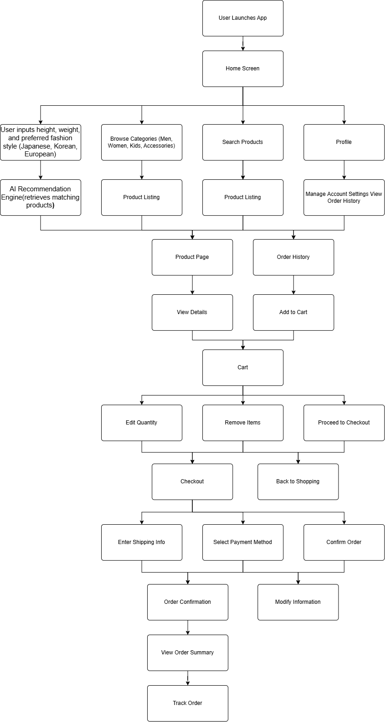

4.1.2 Workflow Diagram (Description)
The workflow diagram visually represents the system’s operational sequence, including the integration of the AI Recommendation Engine. The diagram begins with the Application Launch and flows into the Home Screen, which acts as the central navigation hub for all major user operations.
To the right of the main flow, an additional branch illustrates the AI Recommendation Path. When the user selects the AI Recommendation feature, the system prompts for height, weight, and preferred style (Japanese, Korean, European). These inputs flow into the AI Recommendation Engine, where the model analyzes attributes and retrieves suitable outfit suggestions. The recommended product list is then displayed, and the flow converges seamlessly back into the standard Product Page sequence.
The core browsing flow includes category selection, product searching, viewing product details, and adding items to Wishlist or Cart. This leads to Cart Management and eventually transitions to the Checkout process, which comprises entering shipping details, choosing a payment method, and confirming the order. The diagram then concludes with Order Summary, Order Tracking, and Profile Management.
Overall, the diagram clearly demonstrates the interaction between standard e-commerce functions and the AI-driven personalization feature. The AI path is intentionally placed adjacent to the Browsing Categories block to indicate that users may choose either manual exploration or AI-assisted recommendations, both ultimately leading to the Product Page.

4.2 User Interface (UI) / System Interaction Design

4.2.1 UI Wireframe Description
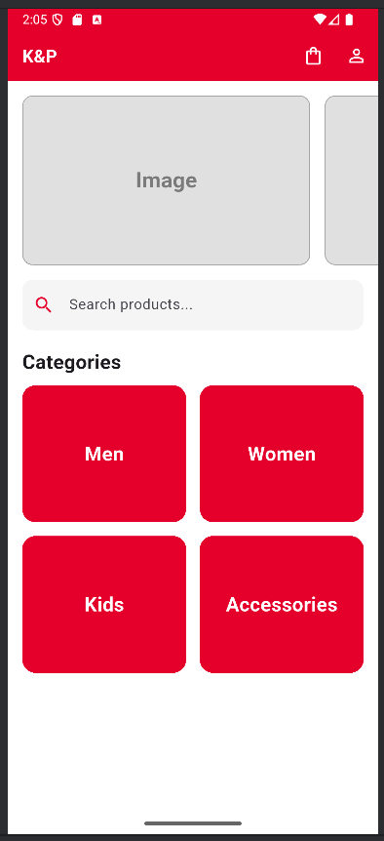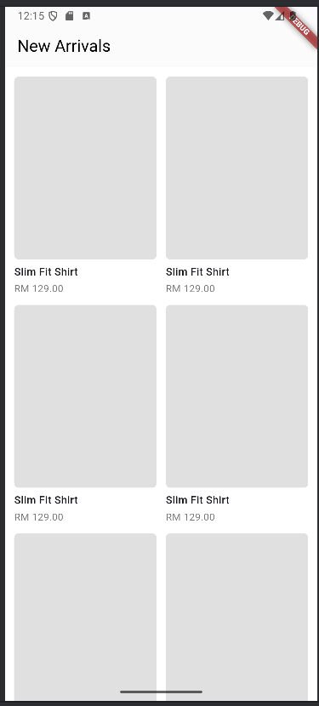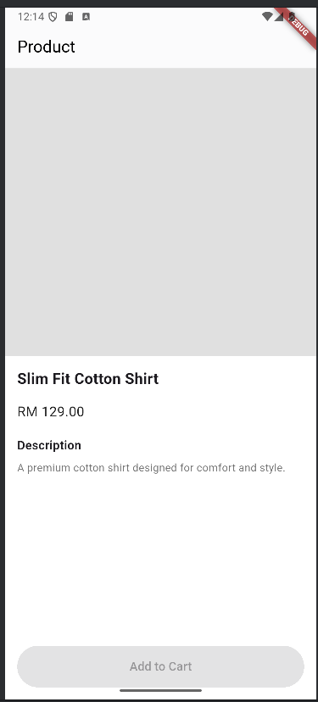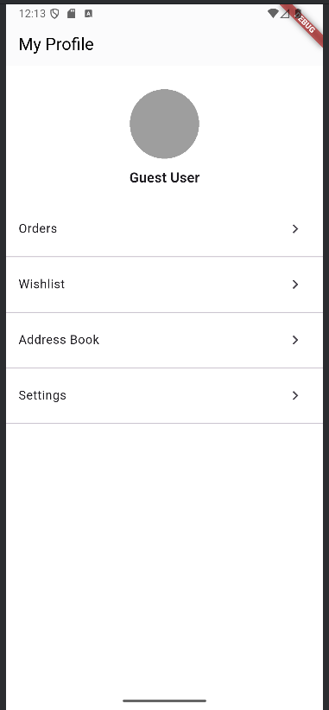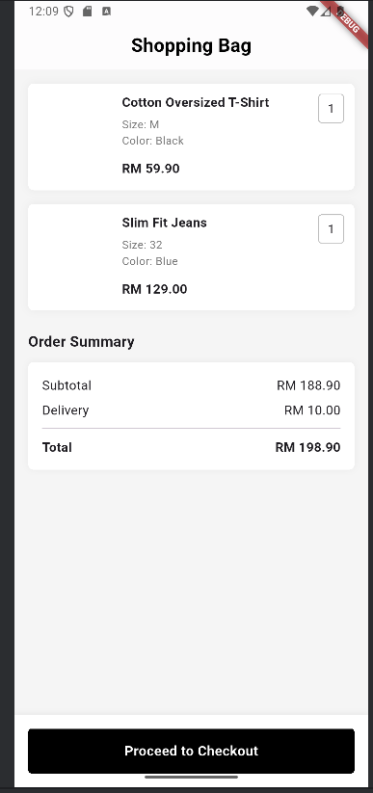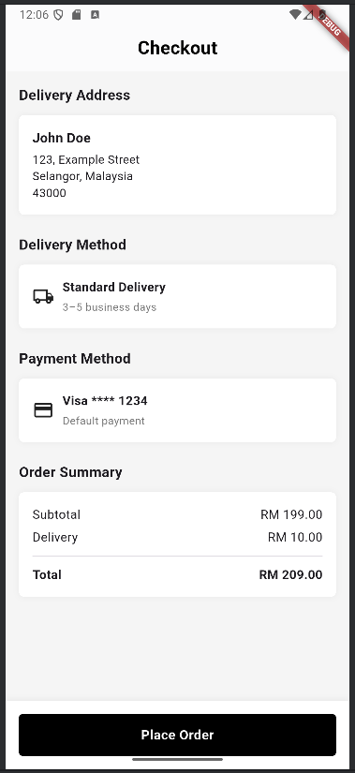
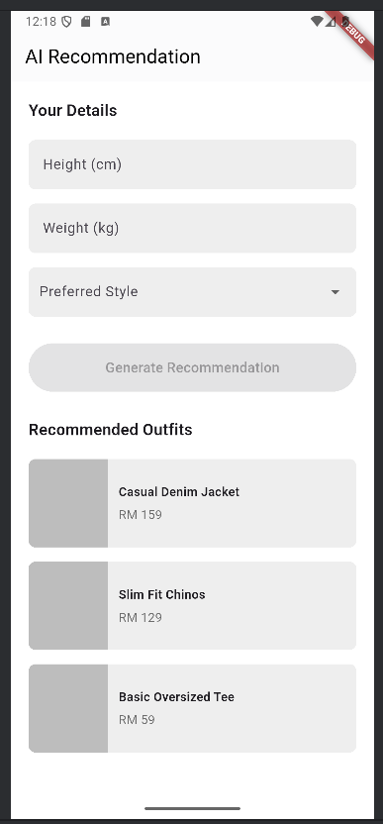

Home Screen
- Shows main shopping categories such as Men, Women, and Unisex.
- Provides quick access to Recommended for You and Trending sections.

Login & Registration Screen
- Allows users to enter email and password.
- Designed for future integration with Firebase/Flutter authentication.

Product List Screen
- Displays products filtered by gender, style, or category.
- Each product card includes View Details and Add to Cart options.

Product Details Screen
- Shows a large product image, price, and description.
- Displays user ratings and comments.
- Includes Add to Cart and Add to Wishlist buttons.

AI Recommendation Screen
- Contains input fields for height, weight, and preferred style.
- A Generate Recommendation button produces a list of suggested outfits.

Cart & Checkout Screen
- Displays all selected items.
- Includes a Simulated Payment option that confirms an order.

User Profile Screen
- Allows users to edit their profile.
- Provides access to order history and wishlist.

4.3 Data Design

4.3.1 Entity Relationship Diagram (ERD)
Your ERD includes these entities:
Entity | Key Attributes
User | user_id, user_name, user_email, user_password, user_gender, user_phone, user_profile_pic, user_update_time, status, role
Category | category_id, category_name
Product | product_id, category_id, product_name, product_pic1, product_pic2, product_pic3, product_pic4, product_description, product_type, product_price, product_status
Quantity | quantity_id, product_id, size, product_stock, product_sold
Cart | cart_id, user_id, product_id, quantity, added_time
Orders | order_id, user_id, delivery_id, order_date, orders_status, order_subtotal
Order_Details | order_id, product_id, quantity_id, quantity, unit_price
Address | address_id, user_id, address_name, recipient_name, phone, address_line1, address_line2, city, state, post_code, country, is_default, created_at
Delivery | delivery_id, address_id, delivery_fee, delivery_status, estimated_date, delivered_date
Payment | payment_id, order_id, user_id, tax, total_amount, payment_method, payment_status, payment_date, discount
Payment_Method | method_id, user_id, method_type, card_type, last_four, cardholder_name, expiry_month, expiry_year
ai_Recommendation | recommendation_id, user_id, height, weight, preferred_style, recommended_products, created_at
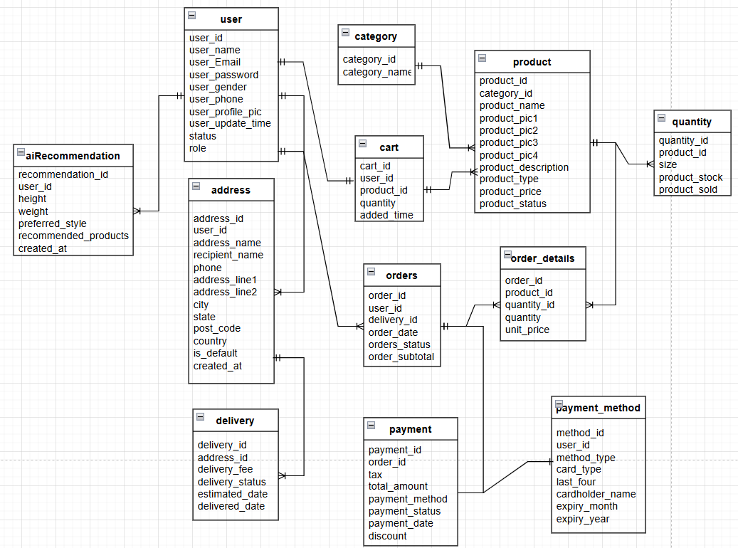

4.3.2 Class Diagram
Class | Attributes | Methods
User | user_id, user_name, user_email, user_password, height, weight, style_preference, gender, phone, profile_pic | login(), updateProfile(), viewRecommendations()
Product | product_id, product_name, category_id, description, product_type, price, status, images[], stock | getDetails(), getStock()
Category | category_id, category_name | listProducts()
Quantity (ProductVariant) | quantity_id, product_id, size, stock, sold | updateStock()
Cart | cart_id, user_id | addItem(), removeItem(), clearCart(), getTotal()
Orders | order_id, user_id, delivery_id, subtotal, order_date, status | placeOrder(), cancelOrder()
OrderDetails | order_id, product_id, quantity_id, quantity, unit_price | calculateSubtotal()
Address | address_id, user_id, name, phone, full_address, is_default | setDefault(), updateAddress()
Delivery | delivery_id, address_id, fee, status, estimated_date, delivered_date | updateStatus()
Payment | payment_id, order_id, user_id, payment_method, payment_date, total_amount | processPayment()
PaymentMethod | method_id, user_id, method_type, card_type, last_four, expiry_month, expiry_year | validate(), remove()
AIRecommendation | recommendation_id, user_id, height, weight, preferred_style, recommended_products | generateRecommendation(), getRecommendedProducts()

4.3.3 Database Schema

Table: User
Field | Type | Description
user_id | varchar | Primary key
user_name | varchar | User’s full name
user_email | varchar | Email address
user_password | varchar | Hashed password
user_gender | enum | Male / Female / Other
user_phone | varchar | Contact number
user_profile_pic | varchar | Profile picture URL
user_update_time | timestamp | Last updated time
status | enum | Active / Inactive
role | varchar | User role (e.g., customer/admin)

Table: Category
Field | Type | Description
category_id | varchar | Primary key
category_name | varchar | Clothing category

Table: Product
Field | Type | Description
product_id | varchar | Primary key
category_id | varchar | Foreign key → Category
product_name | varchar | Product name
product_pic1 | varchar | Image URL 1
product_pic2 | varchar | Image URL 2
product_pic3 | varchar | Image URL 3
product_pic4 | varchar | Image URL 4
product_description | varchar | Description
product_type | enum | Type (e.g., shirt/pants)
product_price | decimal | Product price
product_status | enum | Active / Inactive

Table: Quantity (Product Variant)
Field | Type | Description
quantity_id | int | Primary key
product_id | varchar | Foreign key → Product
size | enum | S / M / L / XL
product_stock | int | Available stock
product_sold | int | Total sold

Table: Cart
Field | Type | Description
cart_id | varchar | Primary key
user_id | varchar | Foreign key → User
product_id | varchar | Foreign key → Product
quantity | int | Quantity added
added_time | timestamp | Added date/time

Table: Orders
Field | Type | Description
order_id | varchar | Primary key
user_id | varchar | Foreign key → User
delivery_id | varchar | Foreign key → Delivery
order_date | datetime | Order date
orders_status | enum | Pending / Shipped / Delivered
order_subtotal | decimal | Final subtotal

Table: Order_Details
Field | Type | Description
order_id | varchar | Foreign key → Orders
product_id | varchar | Foreign key → Product
quantity_id | int | Foreign key → Quantity
quantity | int | Item quantity
unit_price | decimal | Price per item

Table: Address
Field | Type | Description
address_id | varchar | Primary key
user_id | varchar | Foreign key → User
address_name | varchar | Label (Home/Work)
recipient_name | varchar | Receiver name
phone | varchar | Recipient phone
address_line1 | varchar | Address line 1
address_line2 | varchar | Address line 2
city | varchar | City
state | varchar | State
post_code | varchar | Postal code
country | varchar | Country
is_default | tinyint | 1 = Default address
created_at | timestamp | Creation date

Table: Delivery
Field | Type | Description
delivery_id | varchar | Primary key
address_id | varchar | Foreign key → Address
delivery_fee | decimal | Shipping cost
delivery_status | enum | Pending / In Transit / Delivered
estimated_date | date | Expected delivery date
delivered_date | date | Actual delivery date

Table: Payment
Field | Type | Description
payment_id | varchar | Primary key
order_id | varchar | Foreign key → Orders
user_id | varchar | Foreign key → User
tax | decimal | GST / VAT
total_amount | decimal | Final total after tax
payment_method | varchar | Payment type (card/cash/etc.)
payment_status | enum | Paid / Failed
payment_date | datetime | Payment timestamp
discount | decimal | Applied discount

Table: Payment_Method
Field | Type | Description
method_id | varchar | Primary key
user_id | varchar | Foreign key → User
method_type | enum | Card / FPX / E-wallet
card_type | varchar | Visa / Master / Etc
last_four | varchar | Last 4 digits
cardholder_name | varchar | Card holder
expiry_month | int | Expiry MM
expiry_year | int | Expiry YYYY

Table: AIRecommendation
Field | Type | Description
recommendation_id | int | Primary key
user_id | varchar | Foreign key → User
height | float | User height
weight | float | User weight
preferred_style | varchar | Japanese/Korean/European
recommended_products | JSON | AI selected product IDs
created_at | timestamp | Recommendation date

4.4 Software Architecture Design

4.4.1 Layers
- Presentation Layer (Flutter Mobile App)
This layer is built using Flutter and serves as the user interface of the system.
Key responsibilities:
- Display UI components (product cards, recommendations, cart screen)
- Send/receive data through REST API
- Manage app state (e.g., Provider, Bloc, GetX)
- Handle user interactions such as:
  - Logging in
  - Browsing clothing items
  - Adding to cart
  - Viewing recommendations
  - Simulating orders
Flutter ensures cross-platform performance on both Android and iOS.
- Application Layer (Backend API)
The backend handles all the system logic and AI operations.
Key responsibilities:
- Authentication (login, JWT token, sessions)
- Product management (search, filtering, stock updates)
- Cart and wishlist logic
- Order simulation and payment simulation
- AI Recommendation Engine:
  - Dataset preprocessing
  - User style + body measurement analysis
  - ML model inference
  - Generating recommended product list
  - Storing results in AIRecommendation table
The backend returns JSON data to Flutter through REST APIs.
- Data Layer
Responsible for long-term data storage.
- SQL database (MySQL/PostgreSQL) containing:
  - User
  - Product
  - Cart
  - AIRecommendation
  - Order (Simulated)
  - Delivery
  - Payment
- AI model storage
Saved files like .pkl or .h5 for machine learning models.
- Image storage
Could be Firebase Storage or your own backend server.

4.4.2 Architecture Diagram
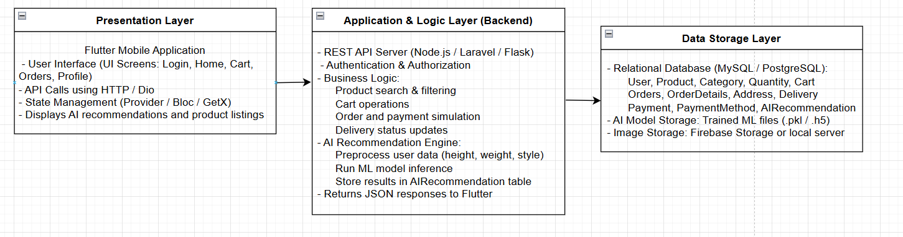

4.5 Process Design

4.5.1 Login Validation Process
- The user enters their email and password in the Flutter application.
- The app sends the credentials to Firebase Authentication for validation.
- Firebase performs the following checks:
  - Whether the email exists
  - Whether the password matches
  - Whether the account is active/verified
- If the credentials are valid, Firebase returns a success response and the user is logged in.
- If the credentials are invalid, Firebase returns an error message (e.g., “Incorrect email or password”).
- The Flutter app displays the corresponding success or error notification.

4.5.2 AI Recommendation Process
- The user inputs body measurement and style information:
  - Height
  - Weight
  - Preferred clothing style
- The Flutter app sends the data to the AI Model API.
- The backend API preprocesses the data and:
  - Filters products based on selected style
  - Applies the ML recommendation model
  - Calculates compatibility scores for each product
- The AI engine generates a list of recommended products.
- The backend stores the results in the AIRecommendation table.
- The API sends the recommended product list back to the Flutter app.
- The app displays the recommendations to the user in the UI.

4.5.3 Simulated Payment Process
- The user reviews items added to the shopping cart.
- The user taps “Proceed to Payment”.
- The system performs a simulated payment operation:
  - The user reviews items added to the shopping cart.
  - The user taps “Proceed to Payment”.
  - The system performs a simulated payment operation:
- The system sets the payment status to ‘successful’ and links the order to a mock payment entry.
- The Flutter app displays the confirmation screen:
  - “Order Successful”
  - Order ID
  - Summary of purchased items

4.6 Algorithm / Model Design
The AI component of the system generates personalized clothing recommendations based on user body measurements, style preferences, and product attributes. The solution uses a Hybrid Recommendation Algorithm, combining Content-Based Filtering with a Lightweight Machine Learning Model.

4.6.1 Algorithm Overview and Justification
Design Element | Description
Algorithm Name | Hybrid Recommendation Algorithm (Content-Based Filtering + ML Scoring)
Justification | Content-based filtering provides accurate matches based on style, while the ML model improves personalization by learning hidden patterns such as user size compatibility and product popularity. This hybrid approach overcomes cold-start issues and works well with small to medium datasets.
Primary Goal | Recommend products that best match the user’s height, weight, gender, and preferred fashion style.

4.6.2 Model Input Features

User Features
- Height
- Weight
- Gender
- Style preference (e.g., Japanese, Korean, European)

Product Features
- Category (Men/Women/Unisex)
- Style
- Type of clothing
- Available sizes
- Price
- Popularity score (based on sales)

4.6.3 Model Architecture

Model Layers
Layer | Description
Input Layer | Encoded user features + encoded product features
Hidden Layer 1 | 32 neurons, ReLU activation
Hidden Layer 2 | 16 neurons, ReLU activation
Output Layer | 1 neuron, Sigmoid activation → outputs compatibility probability (0–1)

4.6.4 Activation & Loss Functions
Component | Description
Activation (Hidden Layers) | ReLU — chosen for fast training and stability
Activation (Output Layer) | Sigmoid — used for binary-like compatibility scoring
Loss Function | Binary Cross-Entropy, suitable for probability predictions
Optimizer | Adam optimizer for efficient training

4.6.5 Compatibility Scoring Formula
Before feeding data into the ML model, the algorithm calculates a baseline compatibility score:
Score=w1(StyleMatch)+w2(SizeFit)+w3(Popularity)Score = w_1(StyleMatch) + w_2(SizeFit) + w_3(Popularity)Score=w1​(StyleMatch)+w2​(SizeFit)+w3​(Popularity)
Where:
- StyleMatch = 1 if matches, else between 0–0.5
- SizeFit = estimated fit from BMI & product sizing
- Popularity = normalized sales count
Weights:
- w1 = 0.5
- w2 = 0.3
- w3 = 0.2

4.6.6 Final Prediction Equation
The final recommendation score combines both algorithms:
FinalScore=0.6(CompatibilityScore)+0.4(MLProbability)FinalScore = 0.6(CompatibilityScore) + 0.4(MLProbability)FinalScore=0.6(CompatibilityScore)+0.4(MLProbability)
Where:
- CompatibilityScore = rule-based score
- MLProbability = neural network output (0–1)

4.7 Security Design

Security Measures Implemented
Area | Design Approach
Authentication | Firebase Authentication (email/password login)
Password Storage | Secure encrypted hashing handled by Firebase (SHA-256 / salted hashing)
Data Privacy | Only minimal data collected; height/weight optional; no sensitive or personally identifiable data stored in AI datasets
Secure Communication | All API requests and data transfers use HTTPS
Database Access Control | Role-based access control (Admin vs User) to restrict product and order management operations
Session Handling | Token-based authentication (Firebase tokens) with automatic expiration
AI Training Data Ethics | User IDs anonymized; no raw personal data used for model training
Local Storage Security | Sensitive values (tokens) stored using secure Flutter storage mechanisms
Input Validation | API validates all inputs to prevent SQL injection and malformed requests

4.8 Chapter Summary and Evaluation
This chapter outlined the system’s design in detail, covering the architectural structure, algorithms, data flow, class and database design, and security mechanisms. A layered architecture using Flutter, a backend API, and a database was defined to ensure scalability and maintainability. The AI recommendation engine design, including model inputs, architecture, and algorithm logic, was also presented to demonstrate how personalized recommendations are generated.
The security design further ensures that user data, authentication processes, and AI datasets are handled responsibly and safely throughout the system.
In conclusion, the proposed system architecture, workflow diagrams, database schema, and algorithm design show that the solution is technically feasible and ready for implementation. The next chapter will focus on developing the system based on this design and conducting functional and performance testing to validate the implementation.

GENERAL FORMATTING, LANGUAGE, AND ACADEMIC WRITING FEEDBACK

